Class of 2016

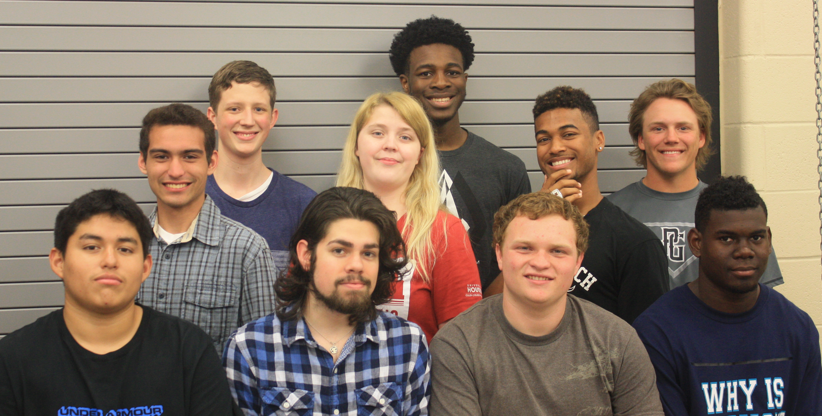

PLTW Completers

Left to Right: Jeff Compean, Zach Matta, Grant Dietrich, Jairon McVea, Luke Allsteadt, Rachel Frary, LeRoy Franklin, Kyle Shulte, Chinedu Okoye, Cody Tiemann